CHAPTER 1: INTRODUCING FLUTTER AND GETTING STARTED

This chapter serves as an introduction to **Flutter**, a powerful framework developed for building applications that work on multiple platforms using a single codebase. It explains why Flutter is a great choice for developers, provides an overview of its key features, and guides to through the process of setting up a development environment and creating my first app. its core concepts, and the necessary steps to set up your development environment. It lays the foundation for building modern, cross-platform mobile applications using Flutter and Dart.

And the necessary steps to set up your development environment. You learned about widgets, elements, and render objects, the structure of the widget tree and element tree, and how to install the Flutter SDK and configure your editor.

This chapter has introduced you to Flutter’s core concepts and guided you through setting up a development environment. By the end of this chapter, you should have a working Flutter installation and be able to run a basic app on your device or emulator.

The next step is to dive deeper into Flutter's building blocks: **widgets**, which are the foundation of Flutter’s user interface.

**INSTALLING FLUTTER SDK**

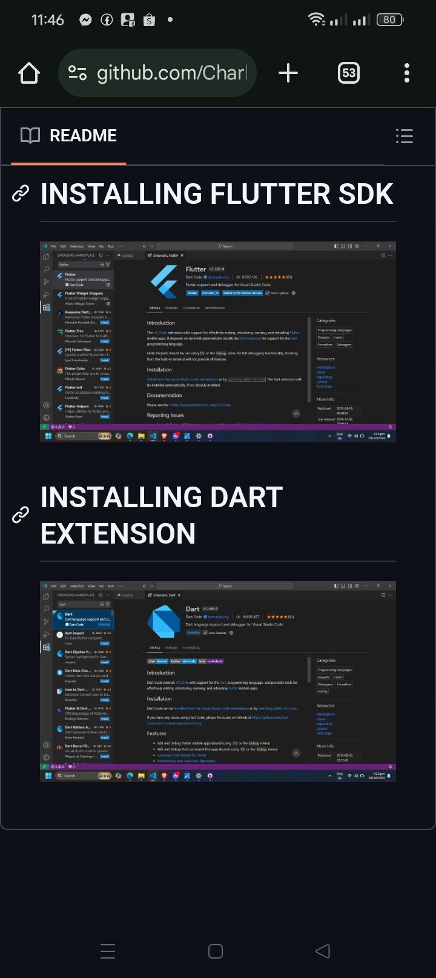

**INSTALLING DART EXTENSION**

